# Unit 6 – Managing a Successful Computing Project

# Part 1: Project Management

## I. Introduction (about the chosen scenario)

- Project management

- Software project

- Project management in software engineering

- Project inception

- Project planning

- Project execution

- Closing

## II. Project initialization (P1)

- Main aim of the project

- List of Objectives to achieve the aim (Note Objective should be SMART)

## III. Project Management Plan: (P2)

1. Scope: *What does the project do and don’t do*
2. Time : *state how many months/weeks/years*
3. Communication: *Type/Frequent Use*
4. Risks: *Name of risk, Priority, Suggestions / Actions*
5. Resources: *Tools (hardware, software) and human*
6. Cost estimation: *identify how many man-month + cost for tools*

## III. Planning (P3)

1. WBS

2. Gantt Chart

# Part 2: Research (P4)

## I .Primary Research:

Overview about Interview/Survey (Who, What, Why, When, Where)

1. List of interview questions (include opened and closed questions)

2. Summary about interview

3. List of survey questions

4. Summary about survey

5. Evaluation about interview and Survey

## II. Secondary research

- Overview: Explain what you will do in the secondary research, its advantages/disadvantages.

- List of articles /books (at least 3 books/2 articles and other internet sources)

- Summarize about articles/Books you have read

- Evaluation about your understanding (

* What you understand
* What you still don’t know or understand
* What can you do if you have more time)

11days 23days

50days

8 days

P4 một số phương pháp định tính và định lượng( lý thuyết). search (Quantitative for project)

* Qualitative

+ Method1

+M2

+……..

+List of survey questions

* Quantitative

+M1

+M2

+List of survey questions

M1 MS

* Intro MS
* Ms capture

Mục tiêu: Sử dụng WBS để phân rả công việc và dễ dàng thực hiện

Nguồn

Hunter, W.C., 2015. The visual representation of border tourism: Demilitarized zone (DMZ) and Dokdo in South Korea. *International Journal of Tourism Research*, *17*(2), pp.151-160.

(Hunter, 2015)

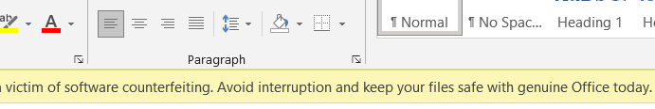

Figure .WBS for